Information for WIS Sample analysis

General info for defect samples
- Preferred sample size is A4, defect in middle
- Apply a number on each sample
- Mark the location of the defect on the edge of the sample sheet (both CD and MD) with short arrows, mark web direction and Top/bottom (picture 1 below)
- Write defect name/type on the sample sheet or prepare a separate list with sample number and name/type (picture 2 below)
- Fill in the return address, if samples should be returned

Customer Data
Company:
Mill:
Line/Machine:
Address:
Submitted by:

Machine/Grade Data
Speed at reel:
Width at reel:
Grade:
Basis weight range:
Is there different colors | Yes/No

Grade Data
Grade:
Basis weight range:
Main colors:
Opacity range:
Number of plies (Board):

Additional info, which might be useful.
Type here

Return address:
Name:
Return Address:
Phone number:
Extra information for return:

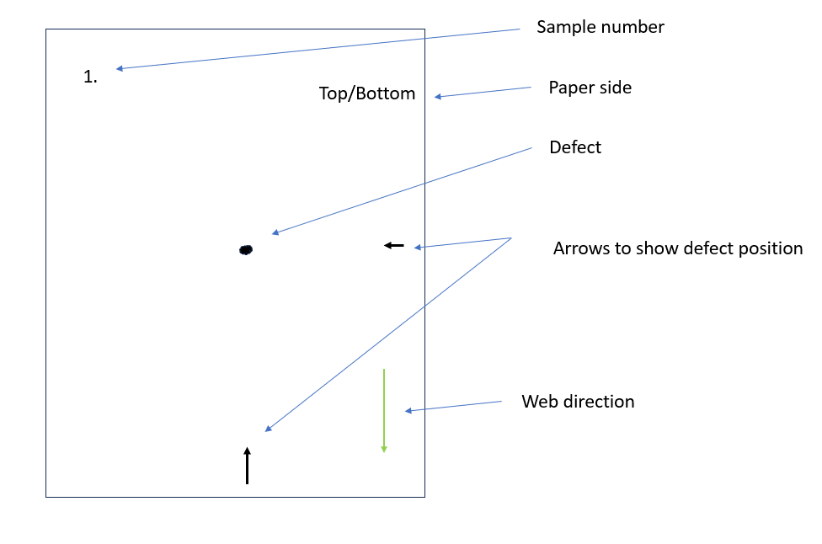
Picture 1.

Sample # | Defect type | Comments
1 | Hole
2 | Dirt spot
3 | Oil drop
4 | Scratch
5 | Streak

Picture 2.

